IKEA Red Smoke

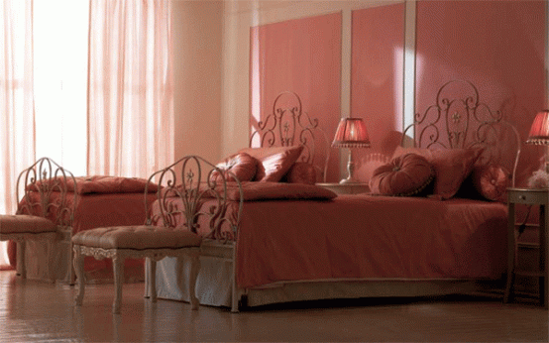

|  |
| --- |
| **DESCRIPTION** |
| IKEA introduces dual stylish bed with a red glow. The metal used in this bed is actually a carbon fiber which is 10 times stronger than steel. Two single beds make it perfect for children who share rooms but do not want to share beds. Carbon fiber is a very strong material which means it cannot break easily so this means that the beds can handle any sort of miss treatment. |

|  |  |  |
| --- | --- | --- |
| **Price** | **1000$ (each)** | |
| **Dimensions** | **H** x **W** x **L** | **20in x 28in x 75in** |
| **Features** | **Two beds include hard air tight mattress which makes it strong enough to not lose its elasticity.** | |
| **Finished** | **Metal Gloss** | |
| **Available in** | **Gold and White** | |